How to onboard trading site PayPal payment

PayPal payment Integration with trading site is based on PayPal checkout button, which is a javascript webpage approach. We have a sample page which show how it could work, you could use it to test with real money for payment.

<https://github.com/biz2013/xwjy/blob/new_paypal/coinExchange/tradeex/apitests/paypal_testclient_sample_prod.html>

Entire client side code is java-script, you could update the sample html and open it in browser directly for testing.

Here is some highlights:

1. **Implement your own API/method to get secret in a secure fashion.**

After fetching it and assign the secret string in the ‘sign’ function <[code location](https://github.com/biz2013/xwjy/blob/new_paypal/coinExchange/tradeex/apitests/paypal_testclient_sample_prod.html#L26)>, this secret is a shared string between your application and trading site, trading site use it as **application identifier**, rely on it to identify which application is sending request. Please keep it secure and use wisely.

1. **Tell trading site payment user id.**

A good practice is sending application internal user id to trading site <[code location](https://github.com/biz2013/xwjy/blob/new_paypal/coinExchange/tradeex/apitests/paypal_testclient_sample_prod.html#L53)>, so trading site could separate and track payment for each individual user, otherwise, it will treat all requests from one application as same user. One bad thing could happen is if one user misbehave it could block all other payments, since trading site couldn’t distinguish who is good or bad.

1. **Set your API Key**

<[code location](https://github.com/biz2013/xwjy/blob/new_paypal/coinExchange/tradeex/apitests/paypal_testclient_sample_prod.html#L73)>, beside secret, trading site will assign you an API key as well, please set the key to yours.

1. **Set payment amount**

<[Code location](https://github.com/biz2013/xwjy/blob/new_paypal/coinExchange/tradeex/apitests/paypal_testclient_sample_prod.html#L60)>, remember, the amount is cent based, if you set num to 100, it’s one RMB Yuan.

1. **Set cad exchange rate**

<[Code location](https://github.com/biz2013/xwjy/blob/new_paypal/coinExchange/tradeex/apitests/paypal_testclient_sample_prod.html#L75)> This is exchange rate from CAD to RMB (ex, 5.46).

1. **Set subject**

<[Code location](https://github.com/biz2013/xwjy/blob/new_paypal/coinExchange/tradeex/apitests/paypal_testclient_sample_prod.html#L59)> This is good to have.

1. **Payment Success**

If everything goes well, one notification will send to <[Code location](https://github.com/biz2013/xwjy/blob/new_paypal/coinExchange/tradeex/apitests/paypal_testclient_sample_prod.html#L118)>, you could redirect the webpage to other place.

1. **Failure & Error handling**

You could handle failure events here <[Error One](https://github.com/biz2013/xwjy/blob/new_paypal/coinExchange/tradeex/apitests/paypal_testclient_sample_prod.html#L97), Payment Creation Failure> and <[Error Two](https://github.com/biz2013/xwjy/blob/new_paypal/coinExchange/tradeex/apitests/paypal_testclient_sample_prod.html#L121), Payment Failure>

**Demo**

1. Load page

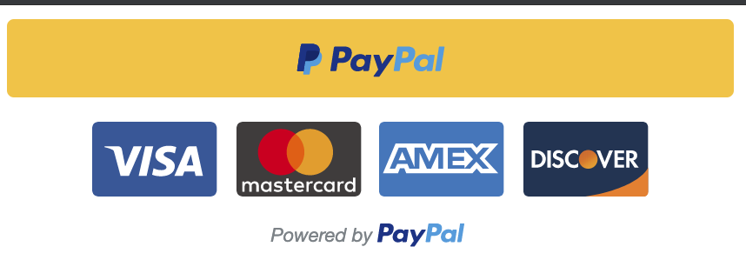

1. Click PayPal button and log in

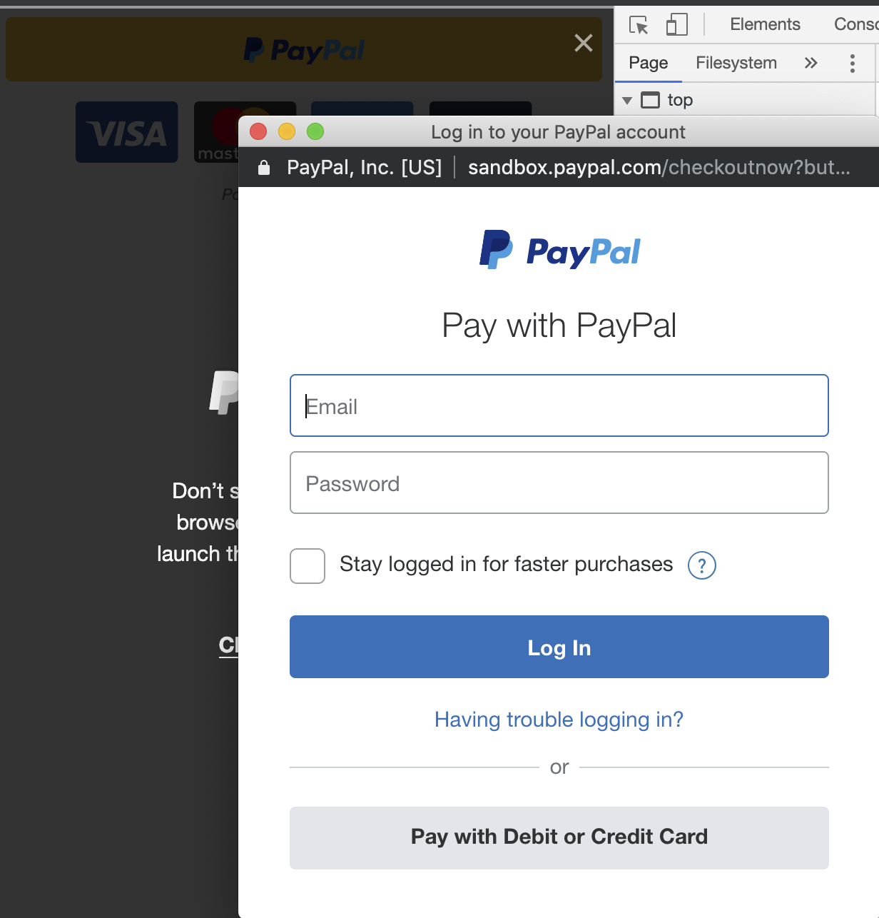

1. Click to continue

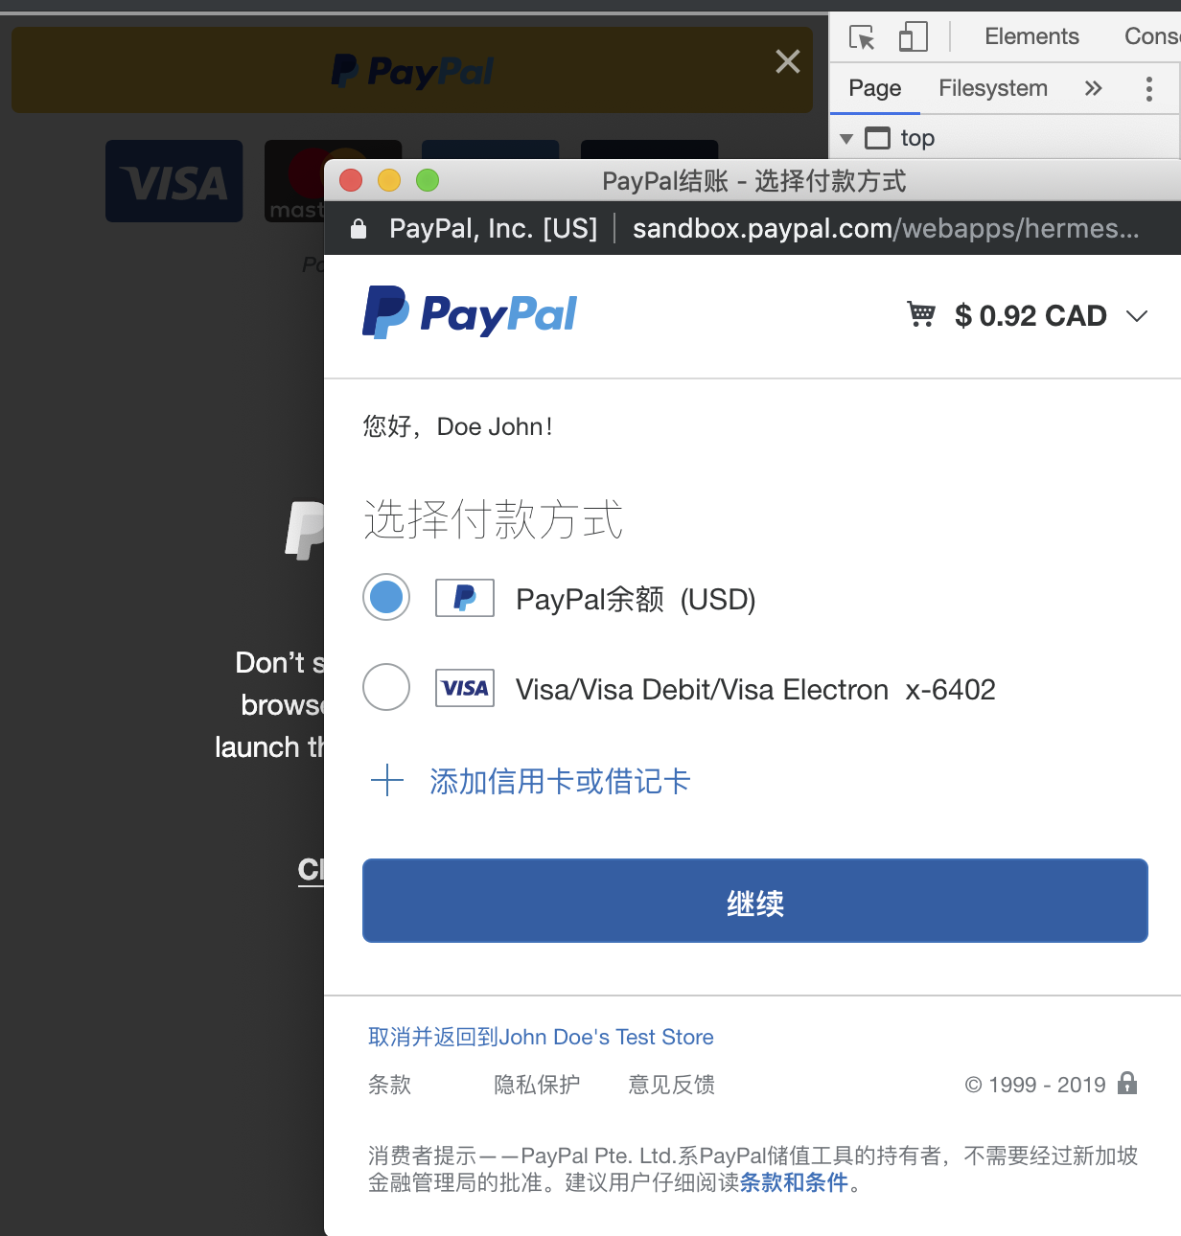

1. Click Pay

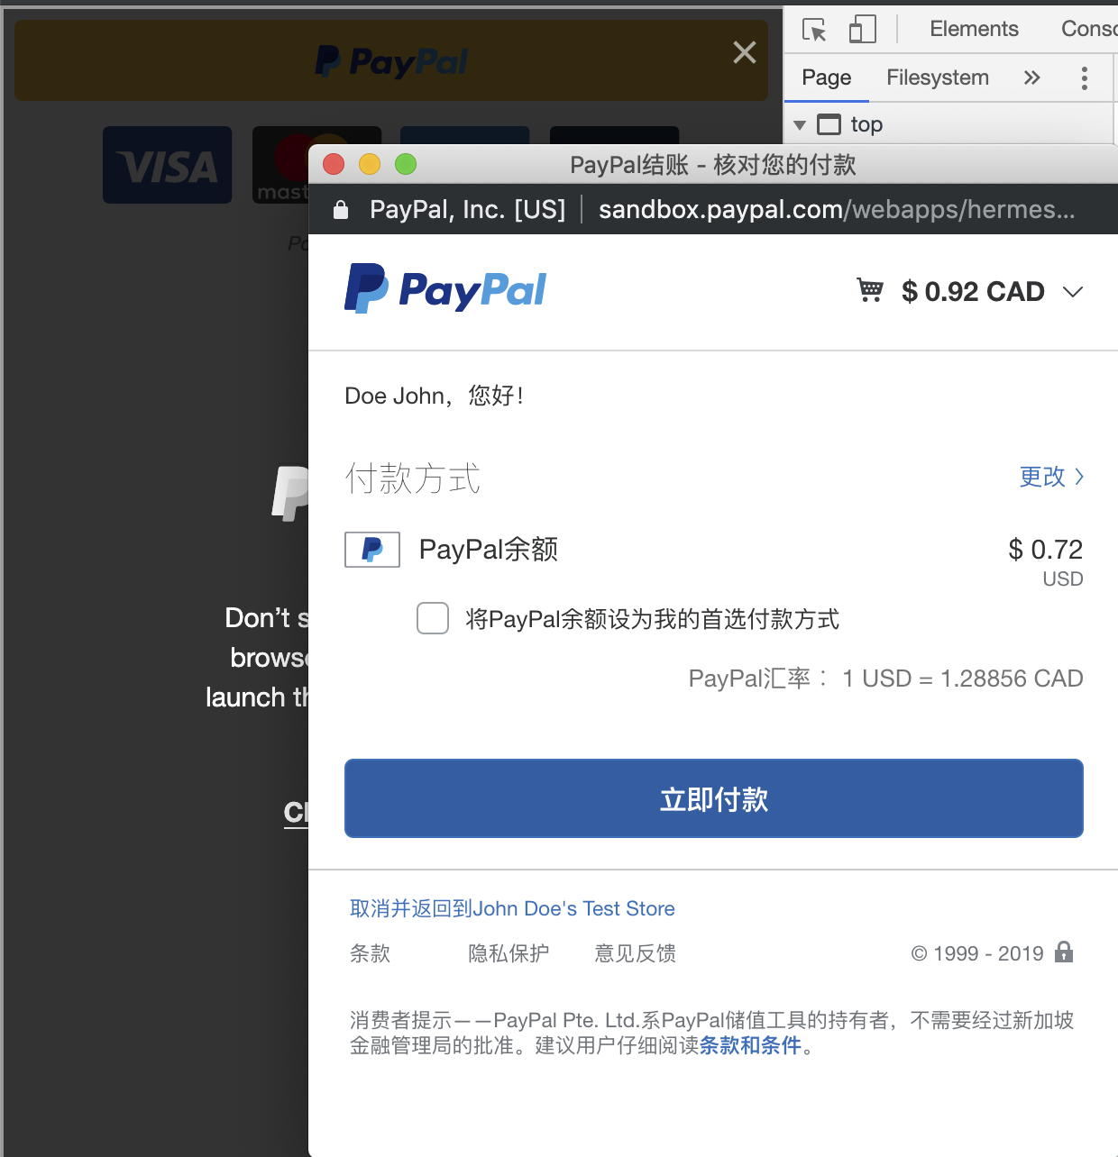

1. Show success popup window

